**ADVANCE EXCEL ASSIGNMENT - 19**

**Q1. What are the data types used in VBA?**

**Ans.** Excel VBA supports a variety of data types that can be used to declare variables. Each data type has specific characteristics and is suitable for different types of data. Here are the main data types in VBA:

1. **Integer:** Stores whole numbers without decimal places. Range: -32,768 to 32,767.
2. **Long:** Similar to Integer but with a larger range. Range: -2,147,483,648 to 2,147,483,647.
3. **Single:** Stores single-precision floating-point numbers (decimal numbers). Consumes less memory than Double but has lower precision.
4. **Double:** Stores double-precision floating-point numbers. Provides higher precision than Single.
5. **Currency:** Stores fixed-point numbers with four decimal places. Useful for financial calculations.
6. **Decimal:** Stores decimal numbers with high precision.
7. **String:** Stores text or a sequence of characters.
8. **Date:** Stores date and time values.
9. **Boolean:** Stores True or False values.
10. **Object:** Represents any object.
11. **User-Defined Types (UDTs):** Allows you to create custom data structures by defining your own types.

Top of Form

**Q2. What are variables and how do you declare them in VBA? What happens if you don’t declare a variable?**

**Ans.** **Variables** in programming are placeholders or containers used to store and manage data in a computer program. They are essential for temporarily holding values that can be manipulated or processed during the execution of the program. In VBA, declare variables to specify their type and allocate memory for them.

**How to Declare Variables in VBA:** In VBA, **Dim** statement (short for Dimension) is used to declare variables. Here's the basic syntax:

**Dim variableName As DataType**

* **Dim**: The keyword used to declare a variable.
* **variableName**: The name you give to the variable.
* **DataType**: The type of data the variable will store (e.g., Integer, String, Double).

**Importance of Variable Declaration in VBA:**

1. **Type Safety:** Declaring variables with specific data types ensures type safety. It helps catch errors early and makes the code more robust.
2. **Memory Allocation:** When you declare a variable, VBA allocates the necessary memory to store values of the specified data type.
3. **Code Readability:** Declaring variables with meaningful names enhances code readability and makes it easier for others (or yourself) to understand the purpose of each variable.
4. **Debugging:** Declared variables provide better support for debugging. The VBA Editor can provide more accurate information about variable types and values during the debugging process.

**What Happens if You Don't Declare a Variable in VBA:** If you don't declare a variable in VBA, it becomes a **Variant** by default. A Variant is a data type that can hold any type of data. While Variants offer flexibility, they have some drawbacks:

1. **Efficiency:** Variants can consume more memory than explicitly declared variables. This may affect the performance of your code, especially in large projects.
2. **Type Safety:** Without explicit type declarations, you lose the benefits of type safety. It becomes easier to introduce errors related to data type mismatches.
3. **Readability:** Code readability may suffer when variables are not declared, as it may be less clear what kind of data is expected.

**Q3. What is a range object in VBA? What is a worksheet object?**

**Ans.** In VBA, a **Range object** and a **Worksheet object** are key elements used to interact with and manipulate data within Excel workbooks. Both objects are part of the Excel object model and provide a way to work with cells, rows, columns, and other elements in a worksheet.

**Range Object:** A **Range object** represents a cell, a group of cells, a row, a column, or a 2D area within a worksheet. It allows you to perform operations such as reading or writing values, formatting cells, and more.

**Worksheet Object:** A **Worksheet object** represents an individual sheet within an Excel workbook. It allows you to perform operations on the entire sheet, such as accessing cells, manipulating data, formatting, and more.

**Q4. What is the difference between worksheet and sheet in excel?**

**Ans.** In Excel, the terms "worksheet" and "sheet" are often used interchangeably, but they can refer to slightly different concepts.

1. **Worksheet:**
   * A **worksheet** in Excel refers to a single spreadsheet or tab within a workbook.
   * Each worksheet consists of a grid of cells organized in columns and rows.
   * Worksheets are where you enter and manipulate data, perform calculations, and create charts and graphs.
   * By default, a new Excel workbook starts with one worksheet, but you can add additional worksheets as needed.
2. **Sheet:**
   * The term **"sheet"** is a more general term that encompasses all types of sheets in an Excel workbook.
   * In addition to worksheets, a workbook may contain other types of sheets, such as chart sheets and macro sheets.
   * A **chart sheet** is a sheet that contains only a chart, while a **macro sheet** is a sheet that stores Excel 4.0 macro code.
   * When people use the term "sheet" without specifying the type, they are often referring to any type of sheet within the workbook.

**Q5. What is the difference between A1 reference style and R1C1 Reference style? What are the advantages and disadvantages of using R1C1 reference style?**

**Ans.** In Excel, the A1 reference style and the R1C1 reference style are two ways of referencing cells, and they differ in how they represent cell addresses.

1. **A1 Reference Style:**
   * **Example:** A1, B2, C3, etc.
   * In the A1 reference style, columns are identified by letters (A, B, C, ...) and rows are identified by numbers (1, 2, 3, ...).
   * This is the default reference style in Excel.
2. **R1C1 Reference Style:**
   * **Example:** R1C1, R2C2, R3C3, etc.
   * In the R1C1 reference style, cells are identified by their row number and column number, denoted by R (row) and C (column). For example, R1C1 refers to the cell in the first row and first column.
   * Columns are represented by the letter "C" followed by the column number, and rows are represented by the letter "R" followed by the row number.

**Advantages of R1C1 Reference Style:**

1. **Consistency in Formulas:** R1C1 reference style can lead to more consistent formulas, especially when using formulas across different ranges. The use of relative references (e.g., R[1]C[1]) can simplify copying and pasting formulas.
2. **Programmatic Manipulation:** When working with VBA (Visual Basic for Applications) or when programmatically manipulating cells, the R1C1 style can be more intuitive and easier to work with, as you directly specify row and column numbers.
3. **Relative Addressing:** R1C1 notation makes it easy to use relative addressing in formulas. For example, R[1]C[1] refers to the cell one row down and one column to the right, regardless of the current cell's position.

**Disadvantages of R1C1 Reference Style:**

1. **Less Familiar for Users:** The A1 reference style is the default and more widely used, so R1C1 can be less familiar for users who are accustomed to the traditional A1 style.
2. **Potential for Confusion:** Users not familiar with R1C1 notation may find it confusing, especially when reading or editing formulas directly in the formula bar.
3. **Compatibility with Formulas:** Some Excel functions and formulas may be designed with the A1 reference style in mind. When using R1C1, it's important to be aware of potential compatibility issues.

**Q6. When is offset statement used for in VBA? Let’s suppose your current highlight cell is A1 in the below table. Using OFFSET statement, write a VBA code to highlight the cell with “Hello” written in it.**

**A B C**

**1 25 354 362**

**2 36 6897 962**

**3 85 85 Hello**

**4 96 365 56**

**5 75 62 2662**

**Ans.** In VBA, the OFFSET function is used to refer to a range that is offset from a starting cell or range of cells.

It takes the following arguments:

Offset(RowOffset, ColumnOffset)

* **RowOffset**: The number of rows to move away from the starting cell. Positive values move down, and negative values move up.
* **ColumnOffset**: The number of columns to move away from the starting cell. Positive values move to the right, and negative values move to the left.

Here's a VBA code that uses the OFFSET statement to highlight the cell with "Hello" in the given table, assuming the current active cell is A1:Top of Form

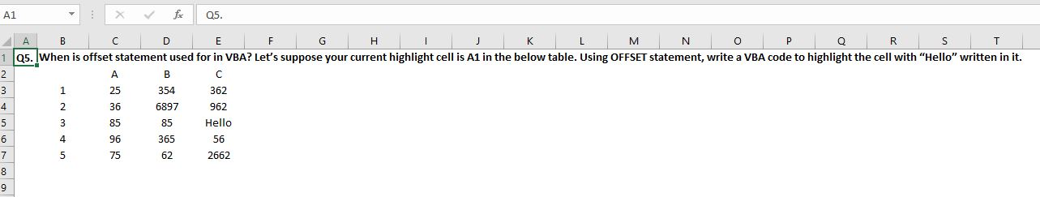

VBA Code is as follows:

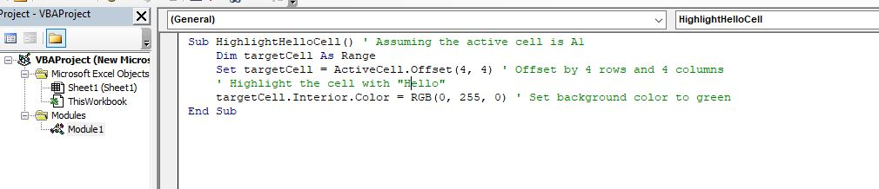Top of Form

Select cell A1. Go to developer tab, click on Macros then choose “HighlightHelloCell” and click Run.

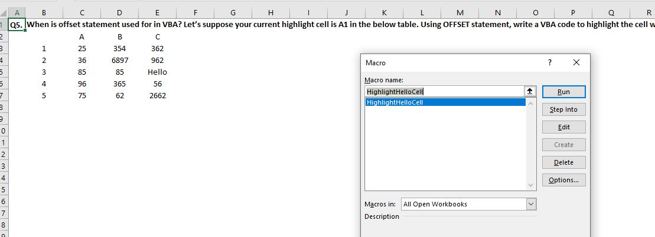

Now the Hello cell is highlighted.

